Analysis:

The pieces of content that are rather associated with one another are in the table below. Things that have to do with volunteerism flow seamlessly into the same category as well as those that have to do with adoption and fostering. Adoption and fostering also closely align with participants placing them both into the same categories. One notable outlier is the “Donate On Pay Pal” card which appears to be more closely related to the volunteer cards but not with other topics that have to do with donations. There seems to be a theme showing donation related topics such as “Memorial or Tribute Donation” and “Coin-Up Change Donation” also being associated with volunteering. Most likely, the connection is that people would like to donate to aid in volunteering efforts.

|  |  |  |  |  |
| --- | --- | --- | --- | --- |
| Apply to Volunte  er | Mission Statement | Adoption Facts | Our Dogs | Memorial or Tribute Donation |
| Volunteer FAQs | Board of Directors | Adoption Process | Rehome Your Pet | Coin-Up Change Donation |
| Donate On Pay Pal | Mclean County Animal Control | Apply to Adopt | Apply to Foster |  |
| Volunteer Opportunities |  | Pay Adoption Fee | Foster Program |  |
|  |  | When Can You Meet Your Puppy | Foster Feedback |  |

On the topic of grouping, let’s look at how people labeled these categories.

As you can see below, general topics regarding staff, mission, and hours are highly associated with business operations or about.



The topics regarding fostering flow nicely into appropriately named categories.



The topics regarding adoption and what dogs are available are highly associated.



Donations and Volunteering are closely aligned according to the survey.

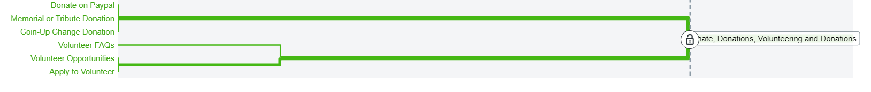

Recommendation:

With all data available to me, I would suggest several things. I would move Mclean County Animal Control to the About Us section. Even though donation and volunteering seem to be closely related, I would keep them in their respective categories as to not cause confusion. I would separate volunteering and fostering on the current website to make it much easier to search for what a user wants. Below is how I lay out the categories:

|  |  |  |  |  |
| --- | --- | --- | --- | --- |
| **ADOPT** | **VOLUNTEER** | **FOSTER** | **DONATE** | **ABOUT US** |
| Our Dogs | Apply to Volunteer | Rehome Your Pet | Donate On Pay Pal | Mclean County Animal Control |
| Apply to Adopt | Volunteer FAQs | Foster Program | Memorial or Tribute Donation | Board of Directors |
| Adoption Facts | Volunteer Opportunities | Apply to Foster | Coin-Up Change Donation | Mission Statement |
| Adoption Process |  | Foster Feedback |  | Hours of Operation |
| When Can You Meet Your Puppy |  |  |  |  |
| Pay Adoption Fee |  |  |  |  |